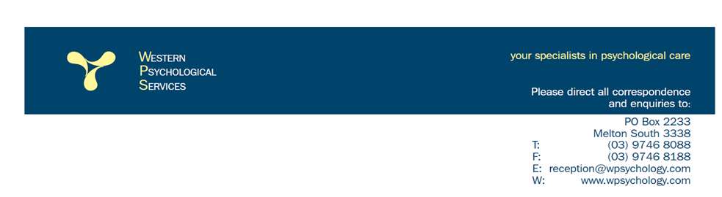**27.03.2020**

**COVID-19 REFERRER UPDATE**

**YES, WPS is OPEN!**

**Continuation of Psychological Treatment during the current Covid-19 Health Pandemic is a priority at WPS.**

This update is to reassure and briefly inform you of the actions we are taking to:

* Ensure continuation of psychological treatment over the coming months &
* Protect your patients and our clinicians from exposure to COVID-19 infection.

### WPS is well prepared

WPS is committed to supporting our clients for their psychological counselling needs. Our offices are open, and we are following Government recommended hygiene and safety protocols.

### WPS can help online

We are quickly establishing systems and ***able to provide Telehealth consultations for all clients*** now and into the future including those with Medicare, TAC, Comcare, TPS (CAREinMIND), NDIS, WorkCover, VOCAT and Open Place referrals.

As the situation is moving quickly, we’ll continue to update our [COVID-19 page](https://e.insurance-email.com.au/pub/cc?_ri_=X0Gzc2X%3DAQpglLjHJlYQGsSu9sUSA0vcDnCdOzdqchCTuI0kRCWbtizfY7zezeTjW2vEle6dzcgh4MyqqanVXtpKX%3DCRBUTBCY&_ei_=EvbWLZ82UVW9xZUqHJi9AdoFgcLh3EC8Ld6MrXR4Fq4DBT_2QzSy9WSx20MXw6KFaa5cfclsg9wAr13QdTZiiRLxiZwqf4Aew4EiWXV9V9OhrDSignL8Eg.&_di_=pq1vb8ltbfqt821ha4tq9lblu0uvh9um2a8ib4dlphsrumpgbg3g) available on www.*wpsychology.com*

In developing our clinic responses, we have drawn on advice from the Department of Health & Human Services, World Health Organisation and the Australian Psychological Society.

For all inquiries please feel free to contact us on (03) 9746 8088

Take care,

Warm regards

Dr Angelo Pagano Fiona Kenna

*BA(M.B.Sc.Pre) PsyD(Clin) Cert. Nsg., Grad Dip (CHN), M.App.Sc. (Management)*

*Director/ Clinical Services Director/Practice Manager*